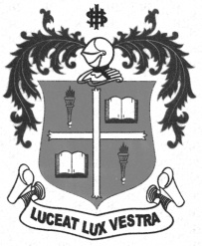
LOYOLA COLLEGE (AUTONOMOUS), CHENNAI – 600 034
M.A. DEGREE EXAMINATION - TAMIL LITERATURE
FIRST SEMESTER – NOVEMBER 2012

TL 1805 - CONTRIBUTIONS OF CHRISTIANS TO TAMIL LITT.

Date : 15/11/2012 Dept. No. Max. : 100 Marks

Time : 1:00 - 4:00



 x=
- 
- 
- 
- 
- 
- 



 x=
- 
- 
- 
- 
- 
- 



 x=
- 
- 
- 
- 
******

